DS 522 Data Acquisition and Analytics
HOS04A – Pandas Basics
08/15/2024 Developed by Catherine Ata
10/16/2025 Reviewed by Ashwin Paturi
2/13/2026 Revised by Jonathan Koerber
04/02/2026 Reviewed by Vishal Krishna Kumar
School of Technology & Computing (STC) @ City University of Seattle (CityU)


Take Note Before Starting
- The directory path shown in screenshots may be different from your directory.
- Not every step is explained in the tutorial. If you are not sure what to do:
  - Consult the resources listed below.
  - If you cannot solve the problem after a few tries, email your course TA for help.

Learning Outcomes
- Understand Pandas' objects, data structures, and functions.
- Learn the basic functionalities and how to use them with Pandas Series and Pandas DataFrames.
- Apply standard data manipulation techniques, such as dropping columns, adding columns, reindexing, filtering, and applying functions to DataFrames.
- Perform basic data exploration, such as viewing summary statistics and identifying missing values.
- Perform mathematical and statistical operations.

Resources
- McKinney. (2022). Python for Data Analysis (3rd edition).
- Tutorials Point. (2024). Python Pandas Tutorial. https://www.tutorialspoint.com/python_pandas/python_pandas_introduction.htm
- User guide. (2024.). Pandas. https://pandas.pydata.org/pandas-docs/stable/user_guide/index.html

Incorporating AI into your Learning Workflow
In this course, we embrace the future of development. Tools like GitHub Copilot, Gemini, and ChatGPT are integrated into modern environments like GitHub Codespaces and VS Code. Our goal is to use these tools not as "answer engines," but as Socratic Tutors. Answer challenge questions by consulting AI tools.
Use AI as a Socratic Tutor to answer the challenge questions throughout this doc and save your responses in a separate document.

Getting Started
- Open the VS Code and, within the VS Code, open the DS522 course folder created earlier. On the menu tab, select File, then Open New Folder. Navigate to your work directory or GitHub repository that you have cloned.
For example:
C:\Users\my_workspace\Desktop\DS522
OR
C:\Users\my_workspace\Desktop\DS522\github_repository_name
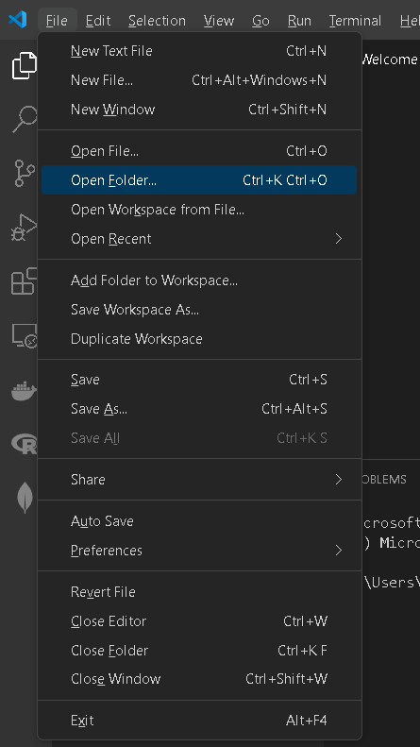

NOTE: If you have cloned a GitHub repository that is explicitly provided for this course, navigate to that directory, and skip steps 2 to 4. This will be the folder where you will be storing all your HOS04A work.
- Once in your work directory, go to the menu tab again, select Terminal, select New Terminal to open a Command Line Interface (CLI) like the Command Prompt or PowerShell for Windows OS.

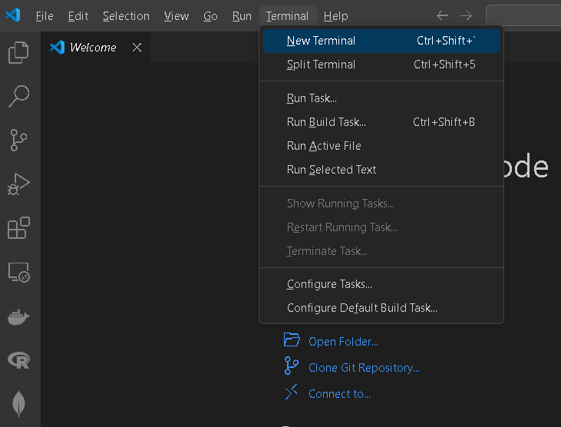
- Inside your “DS522” directory, create a new directory and name it “HOS04A”. Use the following command:
>mkdir HOS04A
- Move to the new directory. Use the following command:
>cd HOS04A

NOTE: This will be the folder where you will be storing all your HOS04A work.
Pandas

What is Pandas?
Pandas – derived from the word “Panel Data” is a powerful Python library that is specifically designed to work on data frames that have "relational" or "labeled" data. It provides high-performance, easy-to-use data structures, and data analysis tools for Python. Its aim aligns with real-world data analysis using Python. Its flexibility and functionality make it indispensable for various data-related tasks. Hence, this Python package is well-suited for data manipulation, operating on datasets, exploring data frames, data analysis, and machine learning-related tasks. Pandas’ versatility and ease of use make it a go-to tool for working with structured data in Python.

Features of Pandas:
- Fast and efficient DataFrame object.
- Tools for loading data into in-memory data objects from different file formats.
- Label-based slicing, indexing, and subsetting of large data sets.
- Columns from a data structure can be deleted or inserted.
- Group data for aggregation and transformation.
- High-performance merging and joining data.

The most common applications of Pandas are as follows:
- Data Cleaning: Pandas provide functionality to clean, messy data, deal with incomplete or inconsistent data, handle missing values, remove duplicates, and standardize formats to do practical data analysis.
- Data Exploration: Pandas efficiently summarize statistics, find trends, and visualize data using built-in plotting functions, Matplotlib, or Seaborn integration.
- Data Preparation: Pandas may pivot, melt, convert variables, and merge datasets based on standard columns to prepare data for analysis.
- Data Analysis: Pandas support descriptive statistics, time series analysis, group-by operations, and custom functions.
- Data Visualization: Pandas itself has basic plotting capabilities; it integrates and supports data visualization libraries like Matplotlib, Seaborn, and Plotly to create innovative visualizations.
- Time Series Analysis: Pandas supports date-time indexing, resampling, frequency conversion, and rolling statistics for time series data.
- Data Aggregation and Grouping: Pandas groupby() function lets you aggregate data and compute group-wise summary statistics or apply functions to groups.
- Data Input/Output: Pandas make data input and export easy by reading and writing CSV, Excel, JSON, SQL databases, and more.
- Machine Learning: Pandas works well with Scikit-learn for data preparation, feature engineering, and model input data.
- Web Scraping: Pandas may be used with BeautifulSoup or Scrapy to parse and analyze structured web data for web scraping and data extraction.
- Financial Analysis: Pandas are commonly used in finance for stock market data analysis, financial indicator calculation, and portfolio optimization.
- Text Data Analysis: Pandas' string manipulation, regular expressions, and text mining functions help analyze textual data.
- Experimental Data Analysis: Pandas make manipulating and analyzing large datasets, performing statistical tests, and visualizing results easy.

In this exercise, we will cover some key features and functionalities of Pandas.

To work with it, we should first install it using a pip command, such as "pip install pandas", and then import it using "import pandas as pd". After successfully installing and importing, we can enjoy the innovative functions of pandas to work on datasets or data frames.

Installing Pandas: Run the command in a terminal: >>>pip install pandas

Core Components
The two primary data structures of pandas are the Series and DataFrame:
- Series - a one-dimensional labeled array holding data of any type, like integers, strings, and objects.
- DataFrame - a two-dimensional data structure that manages and operates data in tabular form (using rows and columns).

A Series is a column, and a DataFrame is a multi-dimensional table made up of a collection of Series.
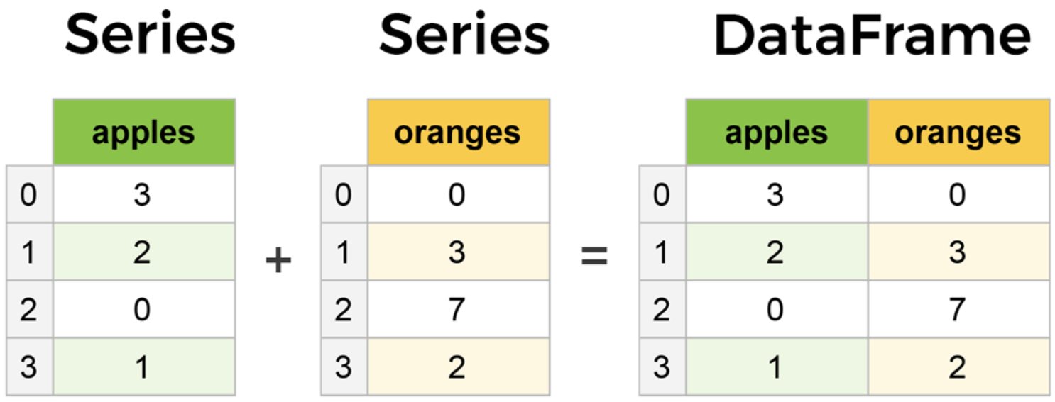
Figure 1. Series and DataFrame Comparison (McIntire, Martin, Washington, 2024)
- In your HOS04A folder or HOS4A repository, create a New File by clicking File on the top menu bar, then New File, and select the Jupyter Notebook option. Save the file with CTRL + S, rename it to pandas_basics.ipynb
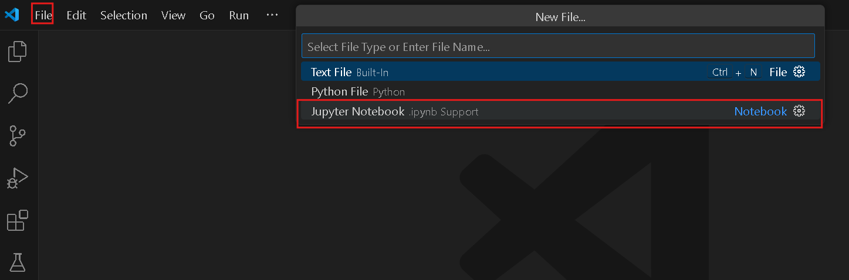

Creating a Pandas Series
- Type the following code in the code cell and then run.

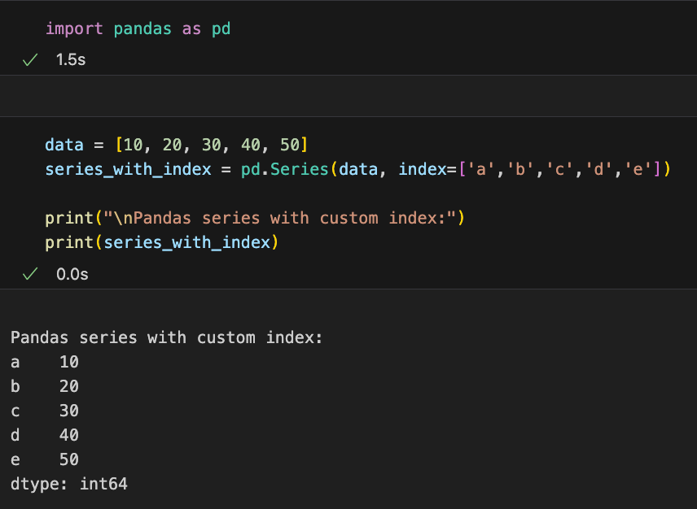

Creating a Pandas DataFrame:
- Hover over the space below the cell you just ran. You will see the +Code button; click on it to add a new code cell to your notebook.
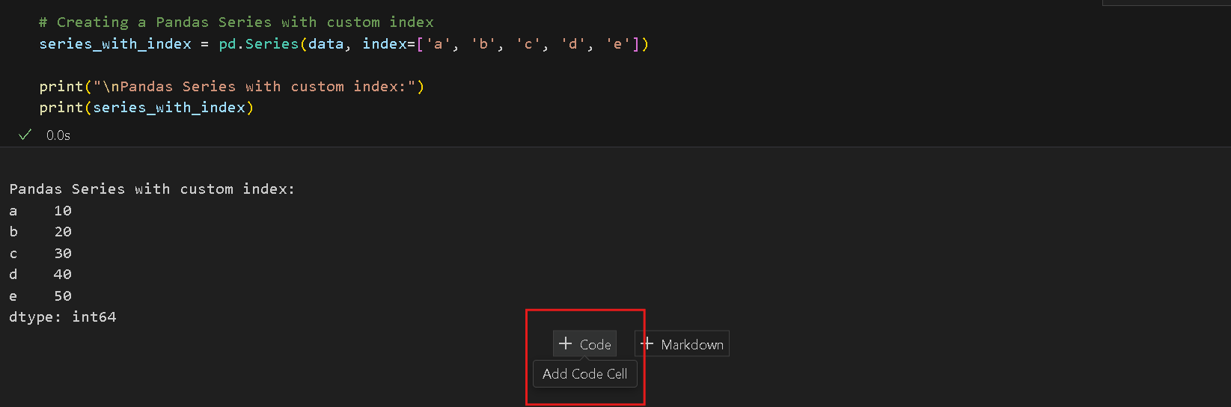
- This time, we are creating a DataFrame from a Python dictionary. Type the following code into the new cell in your notebook, then run the code cell.

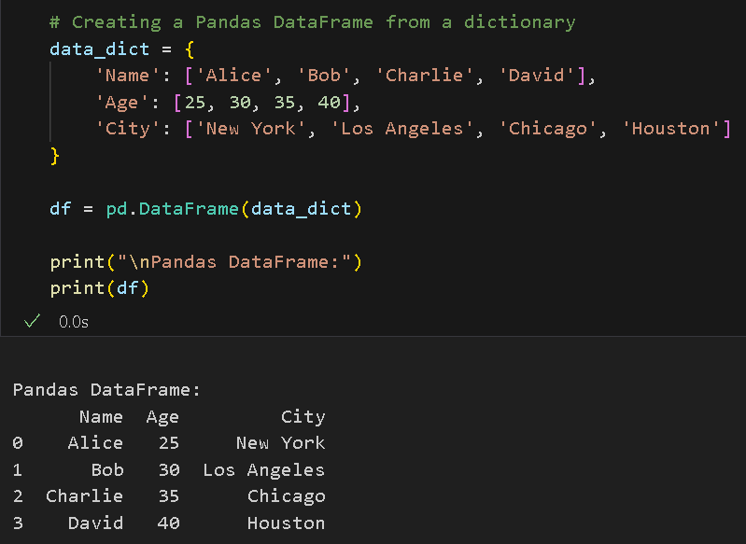

Each (key, value) item in data corresponds to a column in the resulting DataFrame.

Challenge: Using your favorite AI assistant to explain the architectural relationship between a Pandas Series and a DataFrame. Specifically: How is a DataFrame constructed from multiple Series? What happens to the Index when you combine them?
A Pandas Series is a one-dimensional array with an attached index, essentially a single labeled column of data. A DataFrame is built by combining multiple Series, where each Series becomes one column and the shared index acts as the spine that aligns them. When you pass multiple Series into pd.DataFrame(), Pandas matches values by their index labels, not by position. If two Series have different indexes, Pandas takes the union of all labels and fills any gaps with NaN, effectively performing an outer join. So the index isn't just a row number; it's the shared key that holds the entire table together.

- Now, let us create a DataFrame from lists. Type the following code into the new cell in your notebook, then run the code cell.
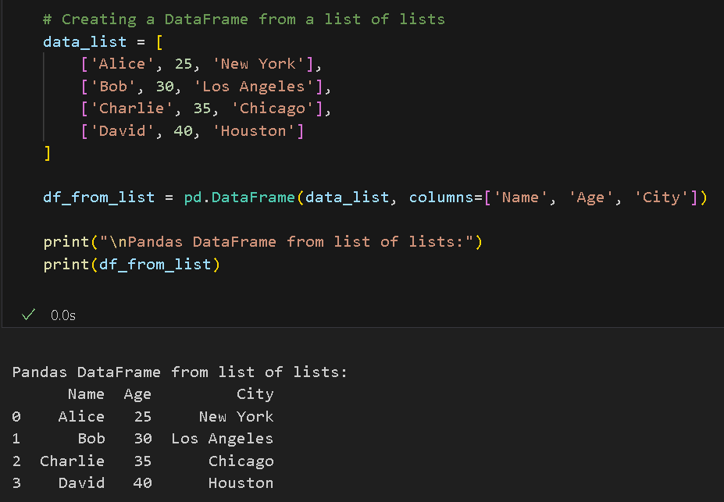

- Let us add a custom index to our data frame. Type this code into a new cell, then run the code.
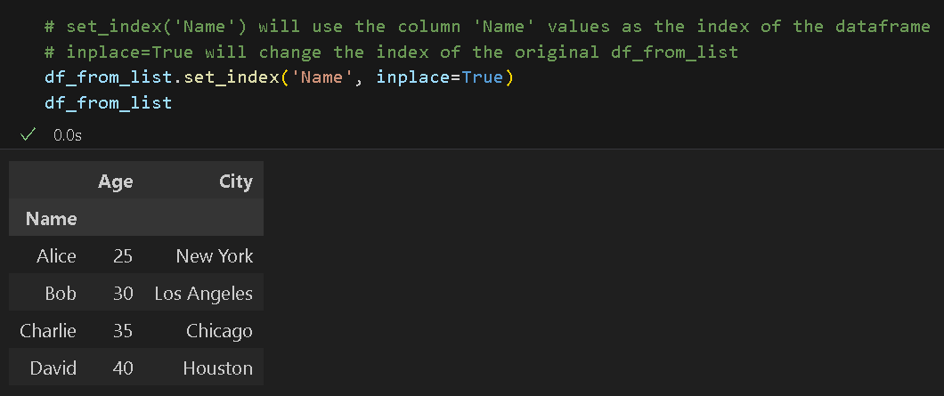

Indexing and Slicing in Pandas DataFrame
- Type the following code in a new code cell to access column values and index values:

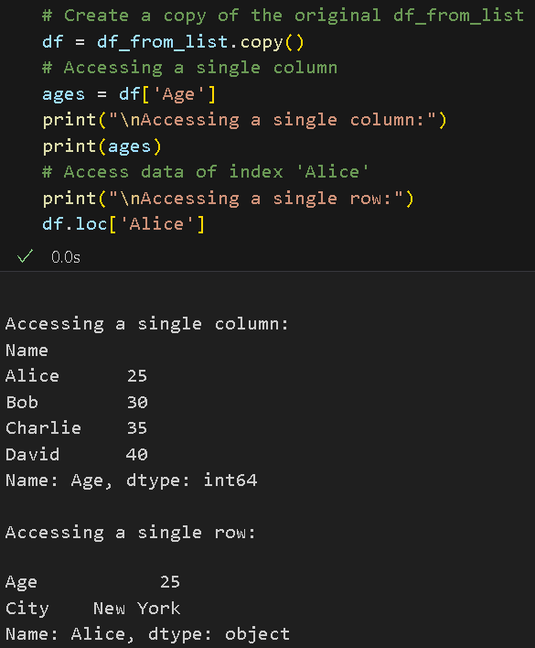

Selecting a single column that yields a Series, in this example, we got a Series of Age values.

- Now, let us access multiple column values. Type the following code in a new cell, run, and check the output.

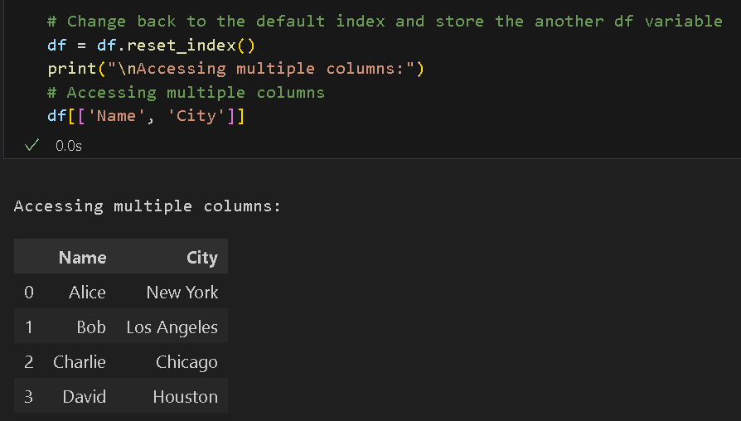

- This time, we are going to access the values of a row index. Add a new cell and type the following code, run, and check the output:

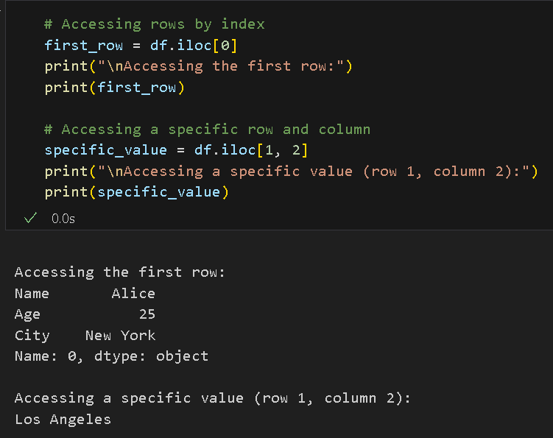

- Using .iloc, this code will access all row values of a specific column index. Type the following into a new cell, then run.
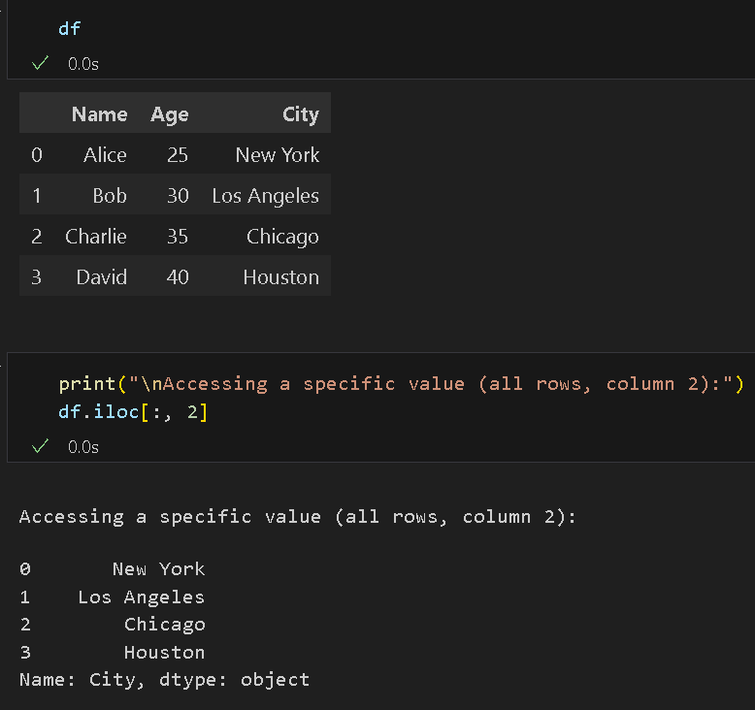

Using iloc is like Python’s slicing; in the example above, the colon ‘:’ accesses all rows, and the two indices access the column in index 2 (the 3rd column).

NOTE: printing the df is just a reference. You may not include that.

- TO DO: Add another code cell, then access the values of all the columns for index 2. Put your code in a separate code cell for each column value.

Filtering Data from a DataFrame
- We can use conditions to filter data in a Pandas DataFrame. Type the following code in a new cell. Run and check the output.

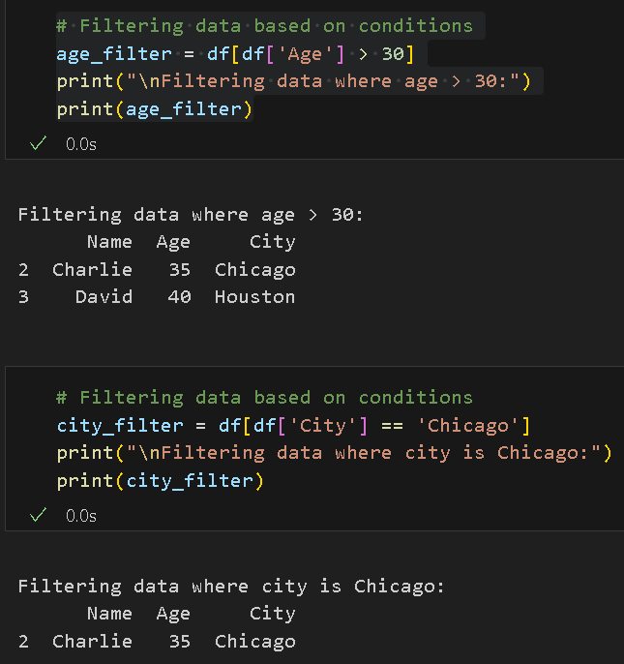
Modifying a Data Frame
- Type the following code in a new cell. Run and check the output. Adding a new column to a DataFrame is as simple as passing a new column name to the DataFrame and enclosing it in square brackets, then assigning the values. The values should be the same length as the rows in the DataFrame.

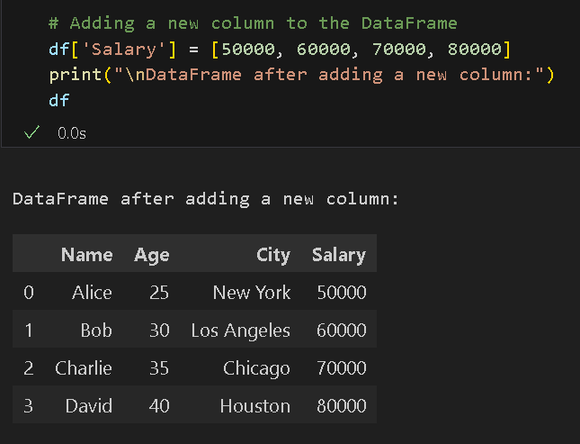

- Let us try adding another column using an existing column and a simple arithmetic operation. Please type this code into a new cell and run it to see the output.
To-Do:
Try adding a new column to the df, and this time, ensure you have enough values in your list. See what will happen.

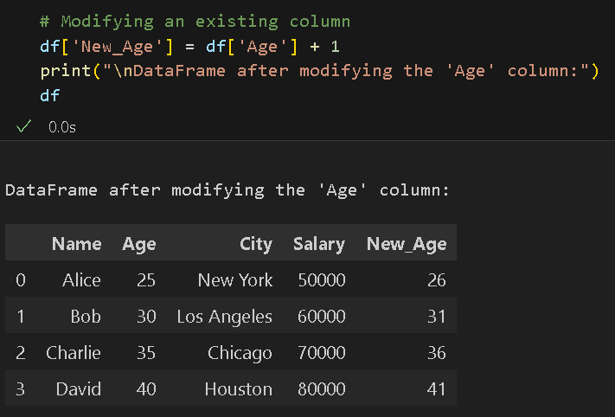

- Let us remove the New_Age column. To do that, we use Pandas' built-in drop function. Type the code below in a new cell. Again, run and see the output.

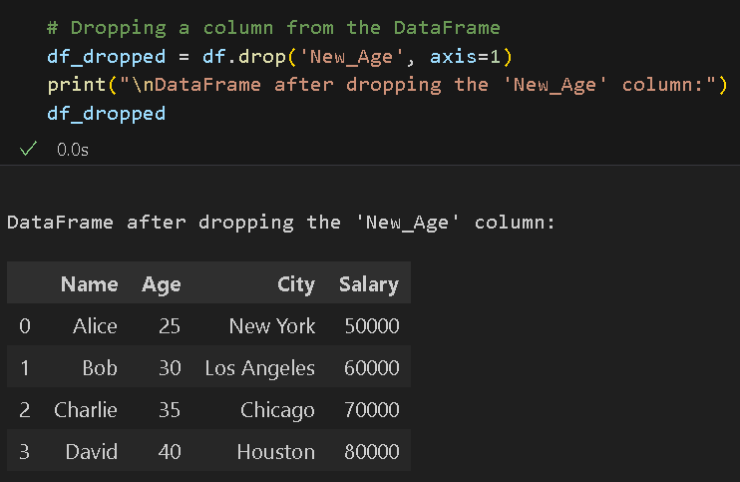

DataFrame Information, Descriptive Statistics, and Basic Operations
- The info() method in pandas provides a concise summary of a DataFrame. It is helpful for quickly understanding the structure of the DataFrame, including the index, column names, non-null counts, and data types of each column. The info() method is beneficial for quickly diagnosing issues, such as missing values or incorrect data types.
- Type the following code to get the information about our DataFrame. Run and check the output.

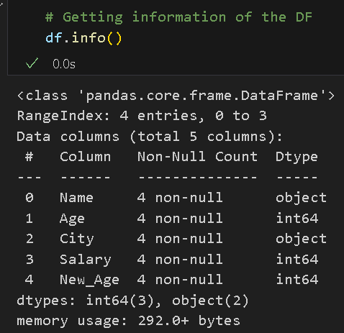

- Type the following code to get the index and column names of the dataframe.

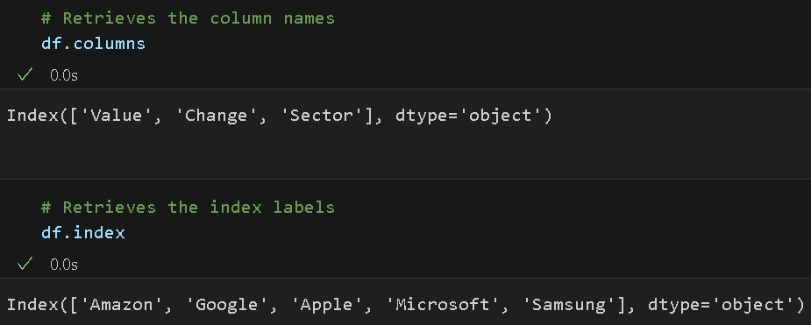

The describe () method in pandas generates descriptive statistics of the DataFrame's numerical columns by default. It provides a quick summary of important statistics, such as mean, standard deviation, minimum, maximum, and percentiles (e.g., 25th, 50th, and 75th percentiles). By default, describe () only operates on numerical columns. However, if you want to include non-numerical columns (e.g., strings or categorical data), you can pass include='all' to the describe() method. The describe () method is a terrific way to get a quick statistical overview of your data!

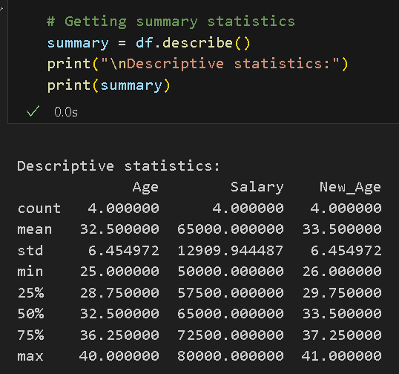
- Type the following code to get the descriptive statistics of our data.Run and check the output

Basic Mathematical and Statistical Operations
- Type the following code into a new code cell in your pandas_basics.ipynb notebook. Run and check the output.

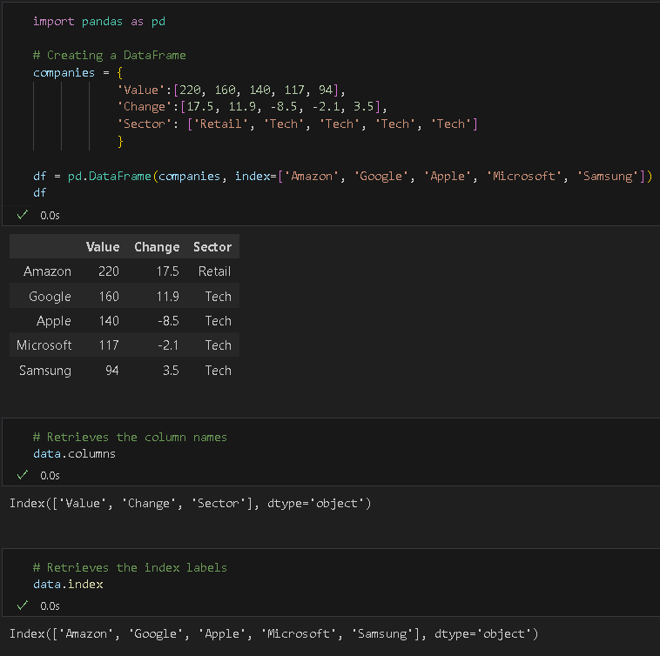

- We can apply mathematical operations such as addition, subtraction, multiplication, and division to DataFrames. Type the following code in a new code cell and run the code to see the output:

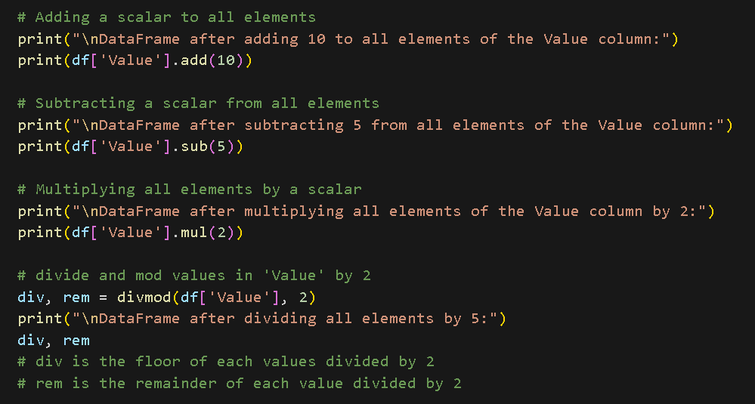

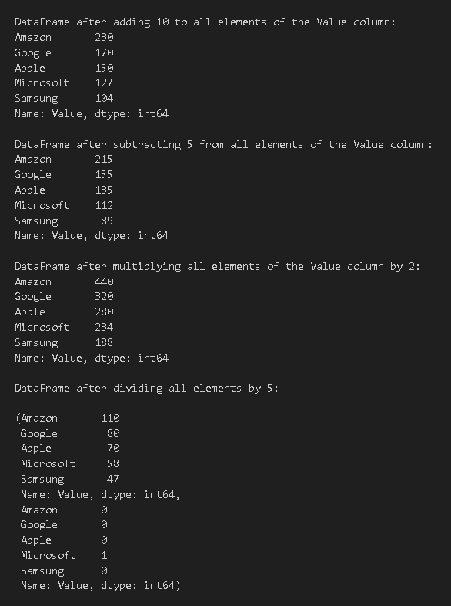
Using the divmod() functions allows us to get the quotient and the remainder of the division operation.
- In addition to functions for mathematical operations, Pandas also has built-in methods for common statistical operations like sum, mean, median, standard deviation, variance, etc. Type the following code in the new code cell to get the sum of all column or row values. Run the cell and check the output.
- We can also compute the mean, median, minimum, and maximum values. Type the following code into a new cell, then run to see the output:

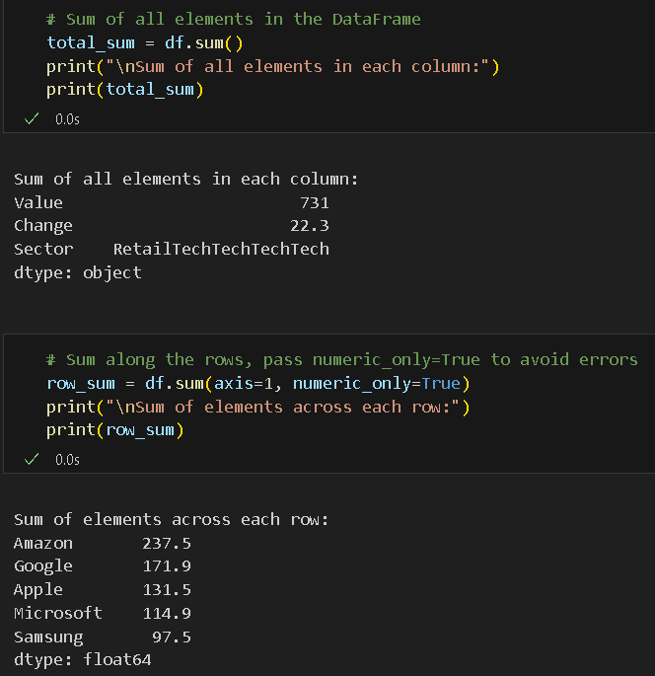
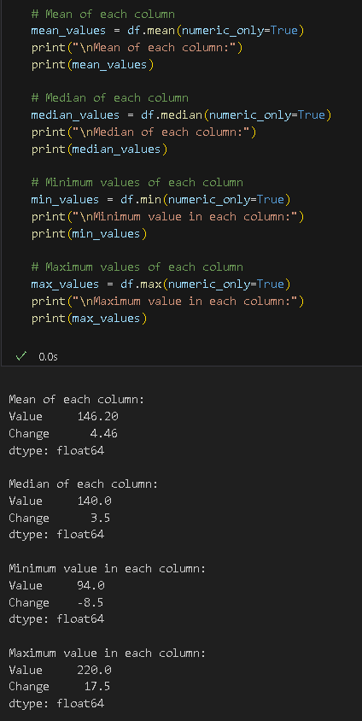

- Now, let us compute the standard deviation, variance, and quantile values. Type and run the code:
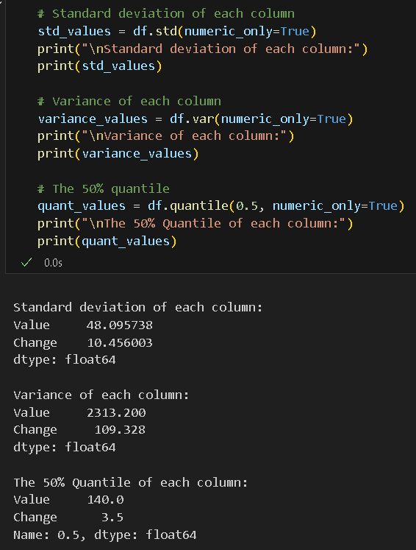

- Pandas also support cumulative operations like cumulative sum, product, etc. Please type this code into a new cell and run it to view the results.

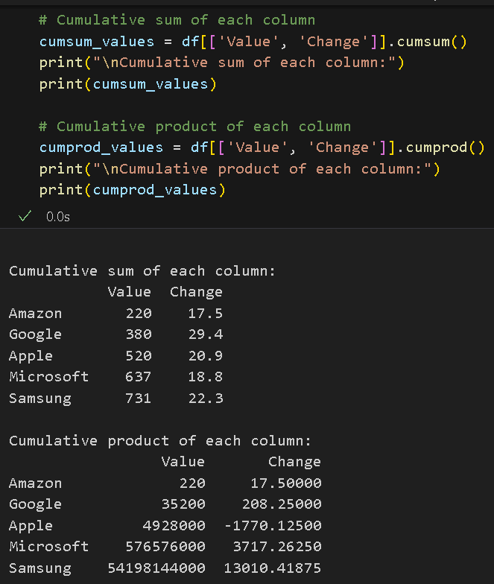
- Additionally, Pandas provides methods to compute correlation and covariance between columns. Add a new cell, then type the code below. Run to view the results.

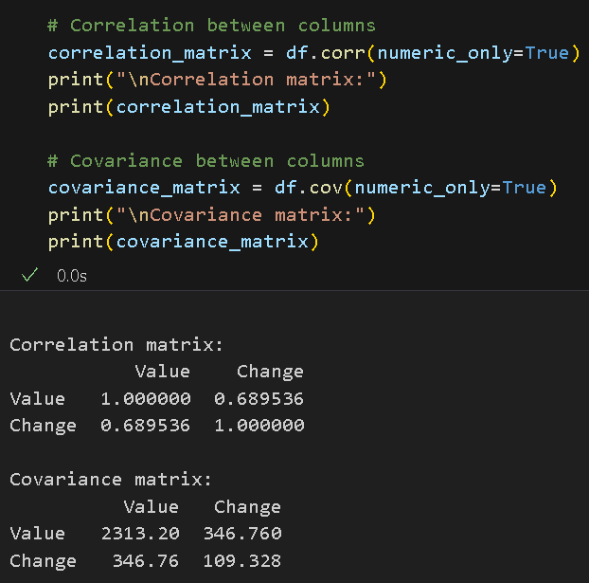

Applying Custom Function
- Pandas allow us to use custom functions on the DataFrame by using the apply() method. Type the following code to create a custom function and apply it to our df. Run the code cell to see the output.

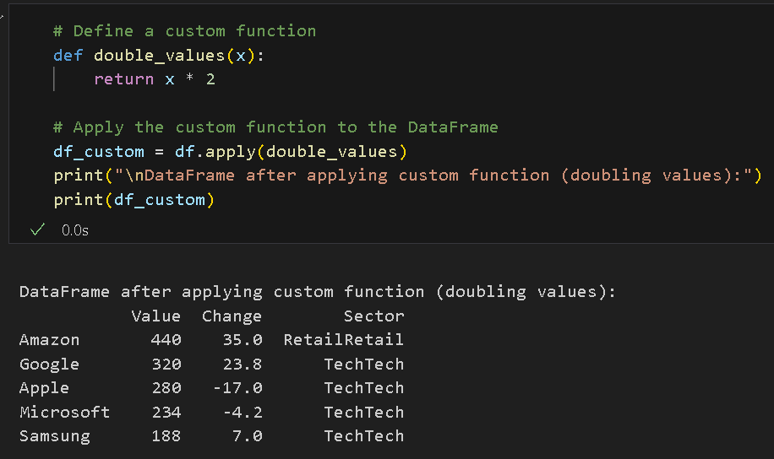
Unique Values and Value Counts
- To get the unique values in a column, we can use pandas’ built-in function unique (). Add a new cell, then type the code below. Run to see the output.

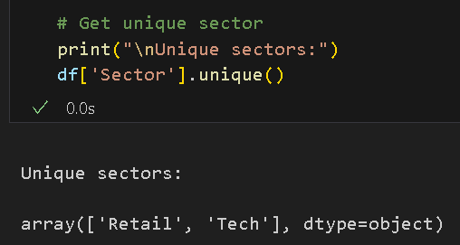

- We can also use pandas built-in function value_counts() to get the number of occurrences for each unique value. Type the following code to a new code cell then run to see the counts.

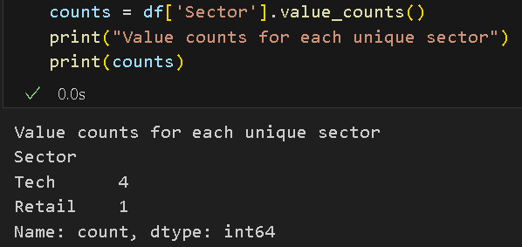

We have covered the basics of the Pandas library, but there is much more that you can do with Pandas. You can learn more here: https://pandas.pydata.org/pandas-docs/stable/user_guide/index.html

Challenge: Contrast the specific computational problems solved by NumPy versus the data-management problems solved by Pandas.
- In your own words, explain why NumPy is considered 'Low-Level' and Pandas is considered 'High-Level.'
- Describe a real-world workflow where NumPy and Pandas work together (e.g., from data cleaning to scientific simulation).
NumPy is "low-level" because it operates directly on raw numerical arrays with no labels, column names, or mixed data types, it's built purely for fast mathematical computation like matrix operations and linear algebra. Pandas is "high-level" because it wraps those arrays in labeled, human-readable structures that handle real-world messiness like missing values, string columns, and date parsing. In a typical workflow, they work as teammates: Pandas loads and cleans a raw dataset, handles grouping and filtering, and then hands off the cleaned numerical data as a NumPy array for heavy computation like statistical modeling or simulation.
*** This is the end of the HOS4A exercise. Please answer HOS04B in Brightspace after pushing your work to GitHub. ***

Push your work to GitHub.
Follow the instructions on the CityU STC TA Center Github.io Submit your work page
You may also follow the instructions below:
- Open the cmd terminal for Windows users,
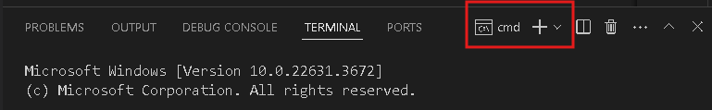

- After selecting the + button, make sure the terminal is cmd if you have not closed the Python terminal. If the terminal is not cmd, then you need to add it by opening the drop-down box and selecting the "Select Default Profile" option.

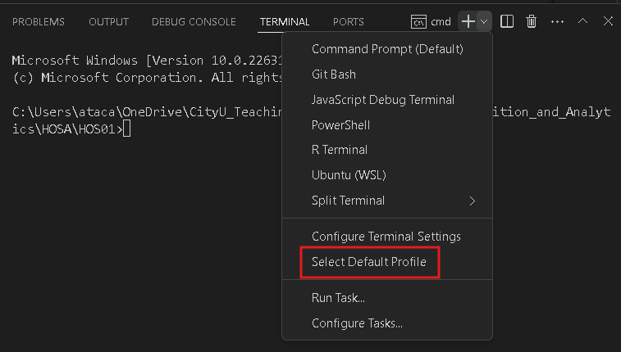

- Look for and then select Command Prompt.

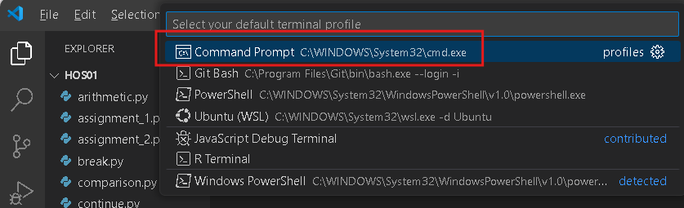

- Click the + button. The command prompt will open.

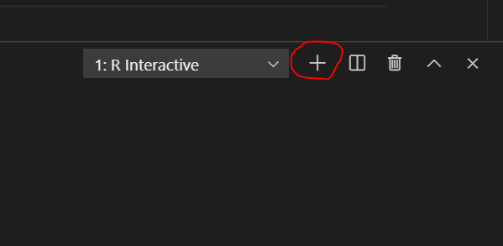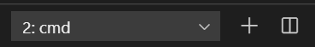

- Make sure you are in the correct directory/repository: Desktop/DS522/hos04a-courseName-yourUserName
- Run the following commands to push your work to the GitHub repository: Open the terminal from VSCode by hitting the control + ~ key and type the following command:
>>> git add .
>>> git commit -m “Submission for HOS04A-Pandas Basics.”
>>> git push

*** Please answer HOS04B in Brightspace. ***

